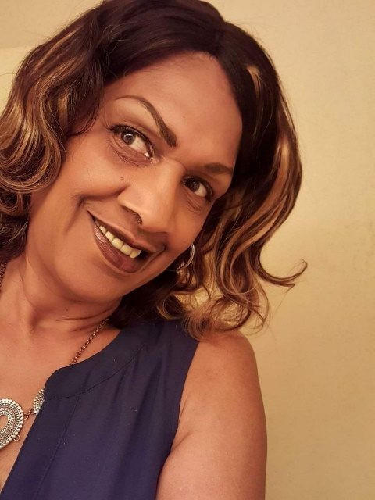

Nedra Williams-Quary

Biography
“About Me”
I was born and reared in Houston, Texas.
I am a graduate of the HoustonISD, and I have been teaching for over twenty-seven years. I attended Texas Woman’s University, Texas Southern, Lamar and Rice University. I received my Masters Certification from University of Houston Downtown. I have one daughter and four grandkids. Two of my grandkids are in college. One is working on her master’s degree, and the middle girl is going to begin her second year at Texas A&M. The boy will be finishing his first year with the Green Bay Packers.
Their parents are active coaches in their school. I coached a girl volleyball team for several years. I love historical fictions, action and romance novels and movies. I love to read!
My goal for this coming year to become better acquainted and prepared with distance learning technology.

